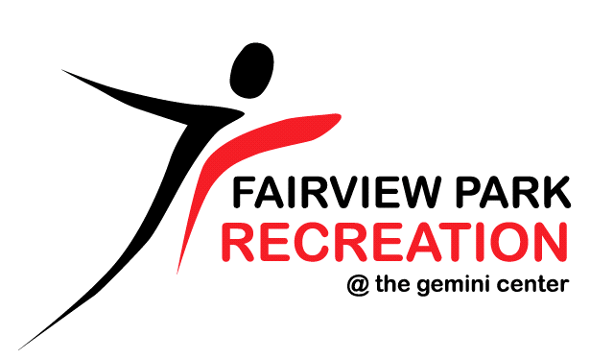
TEEN FITNESS CODE OF CONDUCT
NAME: ____________________________________________
The use of the Gemini Center Fitness Floor is a privilege. The following code of conduct will be adhered to at all times.
- The Fitness Floor is to be used for the sole purpose of exercise.
- The hours between 9a-11a (Monday-Friday) are reserved for Seniors (Age 60+) and those at high risk. Please adjust your workout times accordingly.
- No horseplay, fighting, swearing or abusive language will be tolerated.
- Respect the equipment and the other members utilizing the facility.
- Wipe down all equipment and restack after each use. There are sanitizing stations located throughout the Fitness Floor for your use.
- Cell phone operation is not permitted on the Fitness Floor. This includes making calls, texting, and taking pictures.
- Proper athletic attire (i.e., shoes, t-shirts, non-skid tennis shoes) must be worn.
- A ‘one strike’ policy will be enforced. This means that a single violation to these rules may terminate the right to use the Fitness Floor until the age of 15.

Teen Signature: _______________________________________ Date: _________
Teen Name (Please Print): ______________________________________________
Parent Signature: ______________________________________ Date: _________
Parent Name (Please Print): ______________________________________________

Front Desk Use:
Teen Fitness ID issued: _______

